GenAI Solution Architecture: Automated Medical Record Digitization with Amazon Bedrock Data Automation and AWS HealthLake
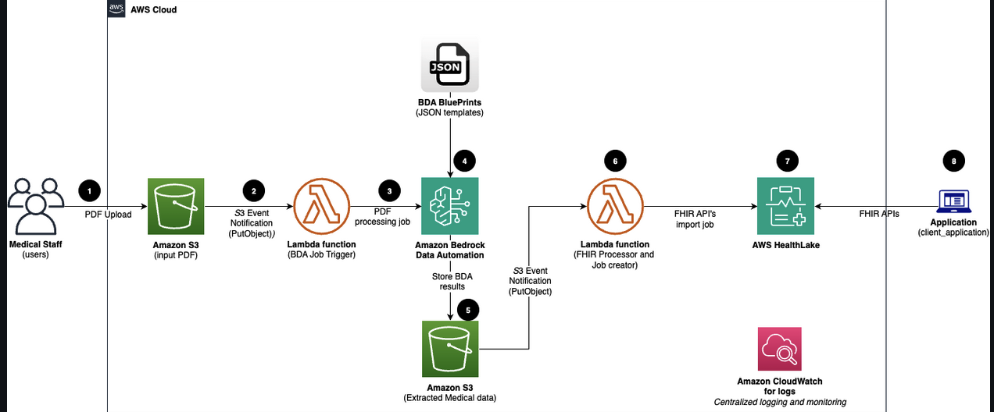

1. Executive Summary
This architecture provides a scalable strategy for healthcare organizations to bridge the gap between historical paper archives and modern clinical ecosystems. By leveraging Generative AI, specifically Amazon Bedrock Data Automation (BDA) and AWS HealthLake, the system automates the extraction of unstructured information from scanned records into standardized, interoperable health data. This solution enables the capture of demographics, diagnoses with ICD-10 codes, medications, vital signs, and lab results. The core value proposition lies in eliminating expensive manual data entry, reducing human error, and closing clinical "care gaps" by making deep patient histories immediately accessible for decision-making.

2. Problem Statement
Healthcare providers manage millions of legacy records that remain siloed from digital workflows, leading to several critical challenges:
- High Manual Processing Costs: Organizations expend significant resources on manual data entry to digitize legacy files.
- Unstructured Data Inefficiency: Information trapped in PDFs or images is not searchable or interoperable with modern electronic health record (EHR) systems.
- Clinician Care Gaps: When historical data is inaccessible, clinicians often make decisions based on incomplete patient profiles.
- Lack of Standardization: Scanned documents do not adhere to industry standards like FHIR, preventing data exchange across healthcare networks.

3. Business Use Case
A regional hospital network holds decades of patient history in scanned PDF format. To modernize, they must transition from "static paper" to "actionable FHIR-compliant data." Implementing this architecture allows the network to automatically process thousands of legacy records, extracting 50+ clinical fields—including complex ICD-10 codes and laboratory results—and indexing them in a secure, searchable data store. This modernization ensures that a patient's full clinical history is available at the point of care, supporting advanced analytics and regulatory compliance.

4. Architecture Overview
This solution is an event-driven, serverless pipeline designed to automate the lifecycle of medical record digitization. It transitions from an ingestion layer into an AI-powered intelligence layer and concludes in a standardized healthcare data store. Utilizing a "Custom Medical Blueprint," the system extracts structured entities without requiring manual template configuration or custom ML model training. Note that this architecture currently supports deployment in the us-east-1 and us-west-2 regions where Amazon Bedrock Data Automation is available.

5. Services and Technologies Used
Service Name,Role in Architecture
Amazon Bedrock Data Automation (BDA),AI intelligence layer; uses a Custom Medical Blueprint to extract 50+ clinical fields and confidence scores.
AWS HealthLake,"FHIR R4-compliant, HIPAA-eligible data store for validating, indexing, and querying health data."
Amazon S3,Provides input/output storage and serves as the event trigger for the serverless pipeline.
AWS Lambda,Orchestrates extraction jobs and transforms AI-generated JSON into FHIR-compliant NDJSON.
Amazon CloudWatch,"Provides end-to-end monitoring, logging, and performance metrics."
AWS CloudTrail,Maintains audit trails for security and compliance across all architectural components.
AWS KMS,Manages customer-managed keys for at-rest encryption in AWS HealthLake and S3.
IAM,"Enforces the ""least-privilege"" security fabric for all service-to-service communication."
AWS CloudFormation,"Provisions the infrastructure as code for repeatable, version-controlled deployments."

6. End-to-End Request Flow
- User Upload: A user uploads a scanned medical record (PDF) to an Amazon S3 input bucket.
- S3 Event Trigger: The upload triggers an S3 event notification that executes the BDA Trigger Lambda.
- Asynchronous Extraction: The Lambda constructs an API call to Amazon Bedrock Data Automation, utilizing a Custom Medical Blueprint to identify 50+ clinical fields (vitals, meds, ICD-10 codes).
- AI Intelligence: BDA processes the document and generates a JSON output containing extracted values and confidence scores (0.0–1.0) .
- JSON Storage: BDA stores the extraction results in the S3 output bucket.
- Transformation Trigger: The creation of the JSON file triggers the FHIR Processor Lambda.
- FHIR R4 Mapping: The Lambda applies validation thresholds based on confidence scores and transforms the JSON into a FHIR R4 Bundle, exported as NDJSON .
- HealthLake Ingestion: The FHIR resources are imported into AWS HealthLake for validation, indexing, and immediate API availability.

7. Data Flow Explanation
- Input Layer: Handles the secure ingestion of raw PDF medical records into the S3 environment.
- Processing/Intelligence Layer: AI-driven extraction using the Medical Blueprint; includes the generation of confidence scores (0.0–1.0) for quality control.
- Transformation Layer: Logic-based mapping where JSON data is converted into FHIR R4 resources and formatted as NDJSON for bulk ingestion.
- Ingestion/Storage Layer: AWS HealthLake validates resources against FHIR R4 specifications and creates relationships between clinical entities.
- Query Layer: Standardized access via FHIR API endpoints, allowing searches by patient, condition, or medication.

8. Architecture Diagram Description
The architecture flows linearly with integrated management:
- S3 Input Bucket initiates a directional arrow to the BDA Trigger Lambda .
- BDA Trigger Lambda sends an asynchronous request to Amazon Bedrock Data Automation .
- Amazon Bedrock Data Automation writes extracted results to the S3 Output Bucket .
- S3 Output Bucket triggers the FHIR Processor Lambda .
- FHIR Processor Lambda pushes formatted NDJSON data to AWS HealthLake .
- AWS HealthLake provides the final FHIR API Query Layer .
- IAM, CloudWatch, and KMS act as a horizontal management layer, providing security, encryption, and observability across every step of the directional flow.

9. Security Considerations
- Least-Privilege IAM: IAM roles are restricted to specific actions (e.g., bedrock-data-automation:InvokeDataAutomationAsync) to ensure no overly broad permissions.
- At-Rest Encryption: All data in AWS HealthLake and Amazon S3 is encrypted using AWS KMS customer-managed keys.
- Storage Privacy: S3 buckets are private by default, with public access blocked and access limited to the pipeline services.
- Comprehensive Auditing: Every API call and system action is captured in AWS CloudTrail for compliance auditing.WARNING: This solution is a demonstration sample designed for use with synthetic data only. It is not production-ready for real Protected Health Information (PHI) as it currently lacks specific HIPAA-required VPC isolation and HITL validation workflows.

10. Scalability Considerations
The serverless stack handles volume through event-driven scaling. Each component activates only when data is present, removing the need for polling. The asynchronous nature of Bedrock Data Automation allows for high-volume batch processing without bottlenecking the pipeline. AWS HealthLake scales indexing and storage automatically to maintain high-performance query speeds even as the dataset grows into millions of records. Deployment is restricted to us-east-1 and us-west-2 to align with service availability.

11. Cost Considerations
Service,Pricing Metric,Estimated Monthly Cost (100 Records)
Amazon Bedrock Data Automation,$0.20–$ 0.30 per page,$20.00 – $30.00
AWS HealthLake,$0.25/GB storage + per query set,$15.00 – $20.00
AWS Lambda,Per invocation / duration,$5.00 – $10.00
Amazon S3,Per GB / per PUT/GET request,$1.00 – $2.00
AWS KMS,$1.00 per key/month,$1.00
Total Estimate,100 Records/Month,$50.00 – $100.00
Note: For production workloads (e.g., 10,000 records), costs scale linearly to approximately $2,000–$ 3,000/month.

12. Monitoring and Observability
System health is managed through Amazon CloudWatch, which monitors for Lambda execution timeouts, BDA job failures, and S3 event delays. AWS CloudTrail provides the security audit trail. A critical component of the strategy is the implementation of a retry-and-alert mechanism for failed extractions, ensuring that documents with low-quality scans are flagged for manual review rather than lost in the pipeline.

13. Risks and Trade-offs
- Accuracy Variability: AI extraction precision may vary based on handwriting quality or non-standard document layouts.
- Image Quality Dependency: Low-resolution scans significantly degrade the AI's ability to extract ICD-10 codes and lab values accurately.
- FHIR Mapping Complexity: Maintaining alignment between AI output and evolving FHIR R4 resource specifications requires ongoing logic maintenance.
- Linear Cost Scaling: Unlike fixed-cost legacy servers, costs grow linearly with document volume, requiring active budget monitoring.

14. Production Readiness Notes
To transition from synthetic data to real Protected Health Information (PHI), the following checklist must be completed:
- Sign and execute an AWS Business Associate Addendum (BAA).
- Deploy all Lambda functions and HealthLake within a private Amazon VPC.
- Use AWS PrivateLink for all service-to-service communication to avoid the public internet.
- Enable Multi-Factor Authentication (MFA) and Role-Based Access Control (RBAC).
- Implement AWS Security Hub with HIPAA compliance checks enabled.
- Enforce TLS 1.2 or higher for all data in transit.
- Implement a Human-in-the-Loop (HITL) workflow for documents falling below a 0.8 confidence score.

